Arrays. Normal  - Reverse Array.  - Binary search.  - Intersection of arrays.  - Shuffle.  - Shift Array  Arrays. Advanced  - Apple Stock.  - Pairs with Given Sum, version 1.  - Pairs with Given Sum, version 2.  - Kth Largest.  - Counting. | String Problems. Easy  - Pig Latin.  - Anagrams.  - Palindrome.  - Reverse String.  - Finding Duplicates.  String Problems. Advanced  - Unique Characters.  - Replace all spaces.  - Reverse words.  - Generate all permutations of string.  - Remove Duplicate.

Arrays. Normal
- Reverse Array. Given an array reverse it.
Hint. Candidate should ask if we want to reverse an array in-place or return a new array.
The answer we want is to reverse in-place.
middle = n/2 // n - size of given array
for i = 0 to middle
temp = a[n-i]
a[n-i] = a[i]
a[i] = temp

- Binary search. Write recursive and iterative versions of a binary search in an array.
Recursive solution:
int binary_search(int A[], int key, int imin, int imax)
{
if (imax < imin) // test if array is empty
// set is empty, so return value showing not found
return KEY_NOT_FOUND;
else
{
// calculate midpoint to cut set in half
int imid = midpoint(imin, imax);
// three-way comparison
if (A[imid] > key) // key is in lower subset
return binary_search(A, key, imin, imid-1);
else if (A[imid] < key) // key is in upper subset
return binary_search(A, key, imid+1, imax);
else // key has been found
return imid;
}
}
Iterative solution:
int binary_search(int A[], int key, int imin, int imax)
{
while (imax >= imin) // continue searching while [imin,imax] is not empty
{
// calculate the midpoint for roughly equal partition
int imid = midpoint(imin, imax);
if(A[imid] == key) // key found at index imid
return imid;
// determine which subarray to search
else if (A[imid] < key)
// change min index to search upper subarray
imin = imid + 1;
else
// change max index to search lower subarray
imax = imid - 1;
}
return KEY_NOT_FOUND; // key was not found
}

- Intersection of arrays. Given 2 arrays find an intersection of them.
Hint. The effective solution should have a time complexity O(m + n) where n and m are sizes of the arrays.
Solution:
- Create a hash table with the keys as item[i] of the shorter array
- Passing through the second array, lookup if the current item is in the hash table
- If it is, save it.
n = arr1.length
m = arr2.length
if n < m
return f(arr1, arr2)
else
return f(arr2, arr1)
def f(arr1, arr2):
hash_table = hash_table with keys as elements from arr1
for i = 0 to arr2.length - 1
if hash_table.has_keys(arr2[i])
add arr2[i] to intersection_array
return intersection_array

- Shuffle. Without using a shuffle or sort write your own shuffle method for an array. The method will take an array and returns a new array with all of the elements in a random order. One important property of a good shuffle method is that every permutation is equally likely.
Hint. The use of a function generated random numbers is allowed.
Solution.
- Passing through array, pick a random number k between zero and the number of unstruck numbers remaining
- move the kth "struck" number to the end of the list by swapping it with the last unstruck number at each iteration.
def shuffle_modern_ver(a): % modern version of Fisher-Yats
from random import randint
n = len(a)
%creating an array for shuffled indices
b = range(n)
for i in range(n-1):
% chose a random number from 0 to n - i - 1
j = randint(0, n - i - 1)
% swap b[n - i - 1] and b[j] elements
% so the next picking will be among unpicked elements of the array
temp = b[n - i - 1]
b[n - i -1] = b[j]
b[j] = temp
c = []
for i in range(n):
c.append(a[b[i]])
return c
- Shift Array Rotate an array by k positions.
Example: Given [1 2 3 4 5 6]
After rotation by 3 will become [4 5 6 1 2 3]

Hint. Candidate should ask if we want to rotate an array in-place or return a new array.
The answer we want is to rotate in-place without using extra memory.

Naive method:
Rotate the one by one (k times)
O(k*n) time if n is array length and K is number rotations

Improved method: Reverse-based with O(n) time
Example: [1 2 3 4], rotate 2
reverse [1 2] and [3 4], get [ 2 1 4 3]
reverse [2 1 4 3] will get [3 4 1 2]

Arrays. Advanced
- Apple Stock. I have an array stockPricesYesterday where the keys are the number of minutes into the day (starting with midnight) and the values are the price of Apple stock at that time. For example, the stock cost $500 at 1am, so stockPricesYesterday[60] = 500. Write an efficient algorithm for computing the best profit I could have made from 1 purchase and 1 sale of an Apple stock yesterday
Solution: We could reformulate this problem as finding the maximum difference between an array elements with indices i and j such i < j and a[i] < a[j].

Straightforward approach (O(n^2)) :
- Passing through the array, calculate all differences between a current element and the following ones
- Keep track of the maximum among these differences
max_diff = 0
for i = 0 to a.length-1
cur_elem = a[i]
for j = i+1 to a.length
diff = a[j] - cur_elem
if diff > max_diff
max_diff = diff
return max_diff
Best approach (linear time)
- We’ll pass through the array keeping two values - current local minimum and the maximum difference obtainable up to this point.
- Passing through the array, check if the next value is a local minimum.
- If the next value is a local minimum, update current local minimum.
- If it is not, calculate the difference and compare to the maximum difference.
- If the new difference is bigger, save this value as the maximum difference.
max_diff = 0
cur_min = a[0]
for i = 1 to a.length
if a[i] < cur_min
cur_min = a[i]
else
if a[i] - cur_min > max_diff
max_diff = a[i] - cur_min
return max_diff

- Pairs with Given Sum, version 1. Given an integer array and a number k return all pairs of numbers that sum to k.
Solution. Best approach is linear in runtime and memory: Use a hashmap such that for key num[i], the value is frequency of occurrence of this element in the array. And for a given num[i], find if (k - num[i]) exists in the map.
printing_pairs(int arr[], int k):
n = arr.length
hash_table = {} // empty hash table
for i = 0 to n-1
if (not hash_table.has_keys(arr[i]))
hash_table[arr[i]] = 1
else
hash_table[arr[i]] = hash_table[arr[i]] + 1
m = number of keys in hash_table
for i = 0 to m-1
cur_key = ith key in hash_table
if hash_table.has_keys( k - cur_key ) and cur_key != k - cur_key
print cur_key, k - cur_key
else if cur_key == k - cur_key and hash_table[cur_key] >= 2
print cur_key, cur_key
- Pairs with Given Sum, version 2. Given two integer arrays and a number k. Return all pairs of numbers that sum to k. Each number of the pair has to be from a different array.
Solution: Use a hashmap such that for key num[i] in the first array, the values is frequency of occurrence. Passing through the values of the second array, find if (k-arr2[i]) exists in the map. To avoid printing same pair several times, zero values of frequency of used elements, for example.
printing_pairs(int arr1[], int arr2[], int k):
n = arr1.length
hash_table = {} // empty hash table
for i = 0 to n-1
if (not hash_table.has_keys(arr1[i]))
hash_table[arr1[i]] = 1
else
hash_table[arr1[i]] = hash_table[arr1[i]] + 1
n_hash = number of keys in hash_table
m = arr2.length
for i = 0 to m-1
cur_item = arr2[i]
if hash_table.has_keys( k - cur_item ) and hash_table[k - cur_item] != 0
print cur_item, k - cur_item
hash_table[k - cur_item] = 0
- Kth Largest. Given 2 arrays of sorted integers return the kth largest element.
Hint. This problem could be reformulated as finding (n + m - k)th element of merged sorted array. Merging 2 arrays of size n and m will take O((n +m)/2) and extra space. This problem can solved in O(log k).

Solution: Two pointers are used, one for array A and one for array B. The basic idea is count K elements from A and B according to the pointers. Assign half of K to each side, cut the smaller array again and again, until (1) the smaller array is empty, output the (K-1)th (array starts from 0) element in the bigger array (2) K=1. Return min(A[0],B[0]).
(modified http://yucoding.blogspot.com/2013/01/leetcode-question-50-median-of-two.html)

def get_kth_elem(A, B, k):
''’ :param A: 1st sorted array with n elements
:param B: 2nd sorted array with m elements
:param k: int, should be less or equal than m+n
:return: kth element among all elements of both arrays
'''
m, n = len(A), len(B)
# assume 1st array is shorter than 2nd
if m > n:
return get_kth_elem(B, A, k)
if m == 0:
return B[k-1]
if k == 1:
return min(A[0], B[0])
# indices to define which side of arrays to consider the next
pa = min(k/2, m)
pb = k - pa

if A[pa - 1] <= B[pb - 1]:
return get_kth_elem(A[pa:], B, k - pa)
return get_kth_elem(A, B[pb:], k - pb)

def find_kth_largest(A, B, k):
n = len(A)
m = len(B)
return get_kth_elem(A, B, n + m - k)
- Counting. Given a sorted array of 0’s and 1’s. Find out the no. of 0’s in it. Write recursive, iterative versions of the code.
[Binary search]

String Problems. Easy
- Pig Latin. Write a method the takes in a string and returns the pig latin equivalent. Pig Latin takes the first consonant, moves it to the end of the word and places “ay” at the end. If the string starts with a vowel do nothing. “pig” -> “igpay”, “banana” -> “ananabay”, “egg” -> “egg”
Solution:
- Check if the input word starts with a constant.
- If it is, create the new word with a suffix according to the rule.
- Return a copy of the input word, otherwise
Possible java Solution:
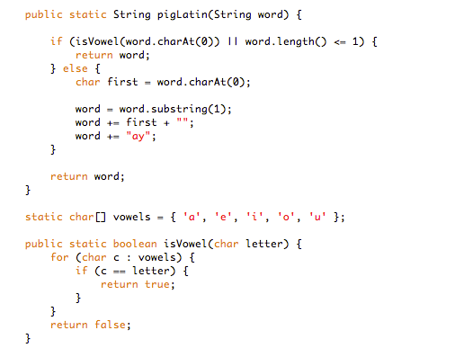
- Anagrams. Write a method to decide if two strings are anagrams or not. An anagram is a word formed by rearranging the letters of another word, e.g., iceman is an anagram of cinema.
Solution:
(ver1)
- Write a function which return lower-cased sorted version a string
- Return a result of comparing lower-cased sorted versions of input strings
(ver2)
- Create an array with 256 zero elements representing ASCII code chart.
- Passing through the 1st string, add 1 to the cell which index corresponds to ASCII code of a current char
- Passing through the 2nd string, check if the cell with the index corresponding to ASCII code of a current char has 0 value
  - If the cell’s value is zero, return False
  - if the cell’s value is non-zero, subtract 1 and continue the loop
- If the loop wasn’t broken, return True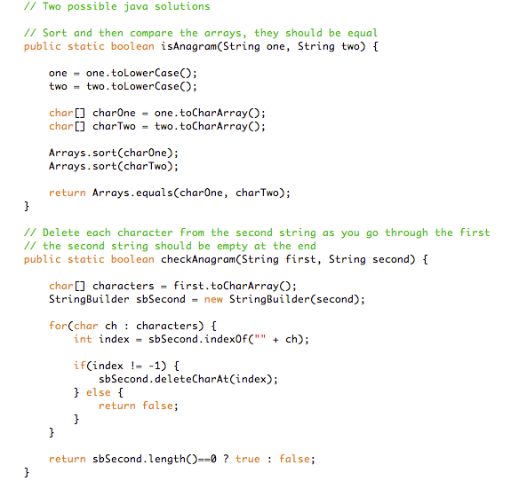

- Palindrome. Determine if a given string is a palindrome. A palindrome is a string that is the same forwards as backwards, ignoring letter case, punctuation marks and word dividers. For example, “racecar” and “Amor, Roma” are palindromes, “abcd” is not. We limit the punctuation marks to ignore by the period, comma, question mark, exclamation point, apostrophe, colon, semi colon and hyphen.
Possible Python solution:

def is_palindrome(word):
n = len(word)
i, j = 0, n-1
while i != j:
a, b = word[i].lower(), word[j].lower()
if a in "., /';:?!-":
i += 1
elif b in "., /';:?!-":
j -= 1
elif a != b:
return False
else:
i += 1
j -= 1
return True

Possible java solution (assumed there are not whitespace or punctuation marks in a given string):
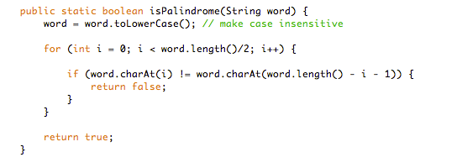
- Reverse String. Write code to reverse a C-Style String. (C-String means that “abcd” is represented as five characters, including the null character.)
Solution:
- Using additional space O(n) and time complexity O(n)
  - Create an empty char array of size strlen(n)+1, initialize with ‘\0’
  - Reverse for loop to copy characters from back of string to front of empty array
  - Return the new array
- Using no additional space and time complexity O(n/2).
Run a for loop from beginning till the middle of the array, continuously swapping characters with the back
swap (s[i], s[s.Length - 1 - i])
- Finding Duplicates. Print out the duplicate elements in a given string.
Hint. This is doable in linear time with a single pass.
Solution:
- Create an array with 256 zero elements representing ASCII code chart
- Passing through the string, check a value at the the cell with the index corresponded to ASCII code of a current char
    - If the value is zero, add 1
    - If the value is bigger zero, it means this char is duplicate
    - Print out the char, if the value is 1
    - Add 1 to the value

String Problems. Advanced
- Unique Characters. Implement an algorithm to determine if a string has all unique characters. What if you cannot use additional data structures?
SOLUTION

You may want to start off with asking your interviewer if the string is an ASCII string or a Unicodestring. We'll assume for simplicity that the character set is ASCII. If not, we would need to increase the storage size, but the rest of the logic would be the same. Given this, one simple optimization we can make to this problem is to automatically return false if the length of the string is greater than the number of unique characters in the alphabet. After all, you can't have a string with 280 unique characters if there are only 256 possible unique characters. Our first solution is to create an array of boolean values, where the flag at index i indicates whether character i in the alphabet is contained in the string. If you run across this character a second time, you can immediately return false. The code below implements this algorithm.
public boolean isUniqueChars2(String str)
{
if (str.lengthQ > 256)
return false;
boolean[] char_set = new boolean[256];
for (int1 = 0; i < str.lengthQ; i++)
{
int val = str.charAt(i);
if (char_set[val])
{ // Already found this char in string
return false;
}
char_set[val] = true;
}
return true;
}
The time complexity for this code is O(n) , where n is the length of the string. The space complexity is O(1).

We can reduce our space usage by a factor of eight by using a bit vector. We will assume, in the below code, that the string only uses the lowercase letters a through z. This will allow us to use just a single int.
public boolean isUniqueChars(String str)
{
int checker = 0;
for (int 1=0; i < str.length(); i++)
{
int val = str.charAt(i) - 'a';
if((checker & ( 1 « val)) > 0)
{
return false;
}
checker |= (1 « val);
}
return true;
}
Alternatively, we could do the following:
- Compare every character of the string to every other character of the string. This will take O(n^2) time and O(1)space.
- If we are allowed to modify the input string, we could sort the string in O(n log(n)) time and then linearly check the string for neighboring characters that are identical. Careful, though: many sorting algorithms take up extra space. These solutions are not as optimal in some respects, but might be better depending on the constraints of the problem.

- Replace all spaces. Write a method to replace all spaces in a string with '%20'. You may assume that the string has sufficient space at the end of the string to hold the additional characters, and that you are given the "true" length of the string. (Note: if implementing in Java, please use a character array so that you can perform this operation in place.)
EXAMPLE
Input: "Mr John Smith"
Output: "Mr%20John%20Smith"
Solution:

A common approach in string manipulation problems is to edit the string starting from the end and work backwards. This is useful because we have extra buffer at the end, which allows us to change characters without worrying about what we're overwriting.
We will use this approach in this problem. The algorithm works through a two scan approach. In the first scan, we count how many spaces there are in the string. This is used to compute how long the final string should be. In the second pass, which is done in reverse order, we actually edit the string. When we see a space, we copy %20 into the next spots. If there is no space, then we copy the original character.

public void replaceSpaces(char[] str, int length) {
int spaceCount = 0 , newLength, i;
- for (i = 0; i < length; i++) {
if (str [i] == ‘ ’) {
spaceCount++;
- }
- newLength = length + spaceCount * 2;
- str[newLength] = ‘\0’;
- for (i = length-1; i >= 0; i--) {
if (str[i] == ‘ ’) {
str[newLength-1] = ‘0’;
str[newLength-2] = ‘2’;
str[newLength-3] = ‘%’;
newLength -= 3;
} else {
str[newLength -1] = str[i];
newLength--;
}
- }
- Reverse words. Given a string containing a set of words separated by whitespace transform it to a string in which the words appear in the reverse order. For example, “Alice likes Bob” transforms to “Bob likes Alice”. We do not need to keep the original string.
Solution (http://www.programminginterview.com/content/strings)
ver 1
- Identify the words by token scanning
- Put them on a stack scanning the string from left to right
- Pop them back off to get the words you inserted in reverse order

Even though that solution would work, it requires a lot of additional space.

ver 2 (in linear time and in-place)
- Reversing the whole string gets the words to their correct relative positions. However, for words that are longer than one character, their letters appear in reverse order. For example, “ram is costly” reversed yields “yltsoc si mar”
- So the next step is reversing the individual words.
void reverseString(char* str, int start, int end) // Reverse string in-place in O(n)
{
if (str == NULL) return;
while (start < end) {
char temp = str[start];
str[start] = str[end];
str[end] = temp;
start++;
end--; }
}
}
void reverseWords(char* input)
{
reverseString(input, 0, strlen(input) - 1); // First reverse the entire string
// Reverse each word
int startWord = 0;
for (int i = 0; i <= strlen(input); i++) {
if (input[i] == ' ' || input[i] == 0) {
reverseString(input, startWord, i - 1);
startWord = i + 1;
}
} }
- Generate all permutations of string. Write a program which generates all permutations of a string. Tell the complexity of the solution.
Solution:
We remove the first character and recurse to get all permutations of length N-1, then we insert that first character into N-1 length strings and obtain all permutations of length N . The complexity is O(N!) because there are N! possible permutations of a string with length N, so it’s optimal. I wouldn’t recommend executing it for strings longer than 10-12 characters though, it’ll take a long time. Not because it’s inefficient, but inherently there are just too many permutations.

def permutations(word):
if len(word) == 1:
return [word]

#get all permutations of length N-1
perms = permutations( word[1:] )
char = word[0]
result = [ ]

#iterate over all permutations of length N-1
for perm in perms:
#insert the character into every possible location
for i in range( len( perm)+1):
result.append( perm[:i] + char + perm[i:])

return result
- Remove Duplicate. Design an algorithm and write code to remove the duplicate characters in a string without using any additional buffer.
NOTE: One or two additional variables are fine. An extra copy of the array is not. Write the test cases for this method.
Solution: Set or HashTable data structure perfectly suits our purpose. It stores keys and provides constant time search for key existence. So, we’ll loop over the characters of the string, and at each iteration we’ll check whether we have seen the current character before by searching the set. If it’s in the set then it means we’ve seen it before, so we ignore it. Otherwise, we include it in the result and add it to the set to keep track for future reference. The code is easier to understand:
def removeDuplicates(string):
result=[]
seen=set()
for char in string:
if char not in seen:
seen.add(char)
result.append(char)
return ''.join(result)
The time complexity of the algorithm is O(N) where N is the number of characters in the input string, because set supports O(1) insert and find. This is an optimal solution to one of the most common string interview questions.
Note: Complexity of insert and find for set or hash table is language and implementation dependent. Average case is mostly constant, but worst case can be logarithmic or even linear. But in an interview setting I think it’s safe to assume constant time insert and find.

